Sermon for Christian Aid Week 2020 Zoom service Psalm 31
However your hands look to you, they are most certainly clean in these days of regular hand washing to prevent spreading the coronavirus.
Our hands really are the most remarkable and useful tools, involved in so much of what we do and how we do things. A large part of our brain is used to control our hands and children spend a lot of their growing learning the finer controls from holding a pencil, threading a needle, playing a musical instrument, to catching a ball. Learning coordination between hands, eyes and brain. Hands are an essential part of our body and they can also be used to express emotions and physical contact. A firm handshake can pass on strength and reliability, a gentle caress tenderness and love, a hand on an arm can convey compassion.
So it is no surprise that the psalmist writes of committing his spirit into God’s hands, and at times of being in God’s hands. This brings to mind images of God holding us in the palm of his hands, enfolding us, protecting us, nurturing us. And with that the understanding that this is not just a physical holding but a holding that is part of all that God is – his love, his compassion, his strength, his support for us. The love that is his nature surrounds and suffuses us.
The psalmist also describes his desire to be delivered from the hands of his oppressors and from the hidden invisible net that threatens to entangle him. We likewise might wish to be delivered from the fear and uncertainty of the coronavirus and the changes it has brought into our societies, and indeed the world. And it is right and proper to ask God for this, to pray this into being.
In these days of social distancing our hands have become even more significant. We might long to hold the hand of a person we can no longer touch. We pray for the hands of medics to bring healing and comfort. We are grateful for hands stacking shelves and delivering groceries and post. And we are extra wary of everything our hands touch that comes from outside our own home.
This Christian Aid Week we also think of how our hands can be far from idle. Though not handing out envelopes, our hands can still reach out virtually to our neighbours around the world. Neighbours in refugee camps and cramped living conditions, neighbours without adequate hand-washing facilities, neighbours who face the devastating impact of coronavirus with even less of the medical resources we have struggled to access here.
We reach out by clasping hands together in prayer for these neighbours, and holding our hands open before God as we declare our needs and concerns for their wellbeing and our own, asking God to hold them in the palm of his hands.
And we reach out also by being open handed, recognising the generous hand God has given to us in what we have and offering handfuls and handfuls of that to those who have far less resources than we do. Sending a cheque or giving online – their income will be less this year because of no street collections, yet the needs will be higher and more severe because of coronavirus. So if you can please support their ministry with a donation.
Also read and share the stories from Christian Aid partners, working on the ground to be the hands and feet of love in action. Pray for them, write to them and let them know that although we cannot do our normal collections we still remember them.
I am going to finish with a poem written by Joseph Addison, in the late 17th century. It reminds us that the whole world is in God’s hands, that everything in nature declares this to be so. (photos up)
The Spacious Firmament on high

The Spacious Firmament on high
With all the blue Ethereal Sky,
And spangled Hea’vns, a Shining Frame,
Their great Original proclaim:
Th’ unwearied Sun, from day to day,
Does his Creator’s Pow’r display,
And publishes to every Land
The Work of an Almighty Hand.

Soon as the Evening Shades prevail,
The Moon takes up the wondrous Tale,
And nightly to the list'ning Earth
Repeats the Story of her Birth:
Whilst all the Stars that round her burn,
And all the Planets, in their turn,
Confirm the Tidings as they rowl,
And spread the Truth from Pole to Pole.

What though, in solemn Silence, all
Move round the dark terrestrial Ball?
What tho' nor real Voice nor Sound
Amid their radiant Orbs be found?
In Reason's Ear they all rejoice,
And utter forth a glorious Voice,
For ever singing, as they shine,
The Hand that made us is Divine.
Amen

Details of Christian partners on https://www.christianaid.org.uk/appeals/emergencies/coronavirus-emergency-appeal
You can make a donation online to help vulnerable communities at https://www.christianaid.org.uk/appeals/key-appeals/christian-aid-week

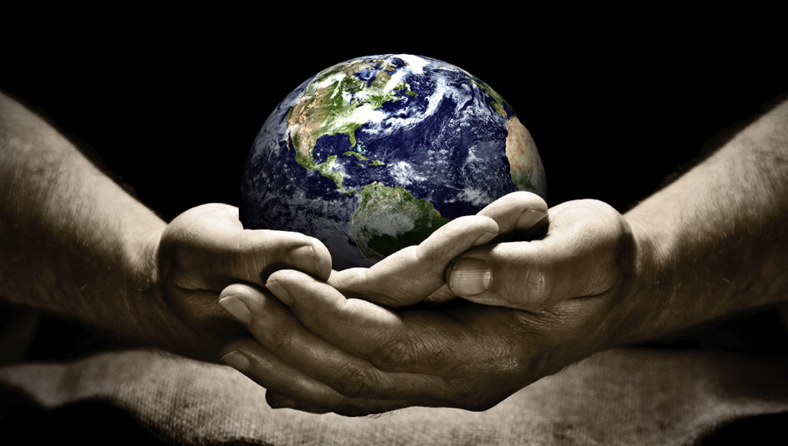

Details of Christian partners on caweek.org.
You can make a donation online to help vulnerable communities at https://www.christianaid.org.uk/appeals/key-appeals/christian-aid-week

